Name : Shreyash Rajesh Shete
Batch : May 2022

SQL Assignment

Library System

Use the following Schema to perform the given set of assignment.

Tables-

Member – It contains information about the members
Column Name | Data Type | Description
Member_Id | Number(5) | Unique Member ID
Member_Name | Varchar2(30) | Name of the Library member
Member_address | Varchar2(50) | Address of the member
Acc_Open_Date | Date | Date of membership
Membership_type | Varchar2(20) | Type of the membership such as ‘Lifetime’,’ Annual’,  ‘Half Yearly’,’ Quarterly’
Fees_paid | Number(4) | Membership fees paid
Max_Books_Allowed | Number(2) | Total Number of books that can be issued to the member.
Penalty_Amount | Number(7,2) | Penalty amount due

Books- It contains information about the books belongs to the library
Column Name | Data Type | Description
Book_No | Number(6) | Book identification number
Book_Name | VarChar2(30) | Name of the book
Author_name | Varchar2(30) | Author of the book
Cost | Number(7,2) | Cost of the book
Category | Char(10) | Category like Science , Fiction etc.

Issue – It contains the information about issue of the books

Column Name | Data Type | Description
Lib_Issue_Id | Number(10) | Library Book Issue No
Book_No | Number(6) | Number of the book issued
Member_Id | Number(5) | Member that issued the book
Issue_Date | Date | Date of Issue
Return_date | Date | Return date

Day # 1 Assignments (Estimated Time: 2 Hrs)

Concept: SQL Basics,
DDL commands- Create table without constraints and with constraints, Alter, truncate, and Drop
DML commands Insert, Update, Delete,
Transaction Control Commit, Rollback, Savepoint.
Create sequence command

Objective: At the end of the assignments, participants will be able to understand basic DDL / DML/ Transaction Control statements.

Task / Problems:

- Create the table Member, Books and Issue without any constraints as mentioned in the schema description above.

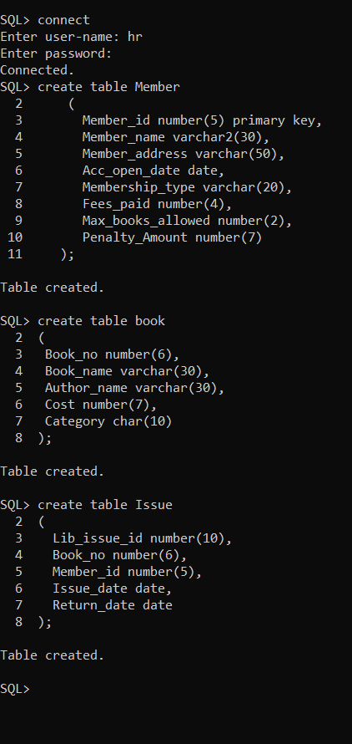

- View the structure of the tables.

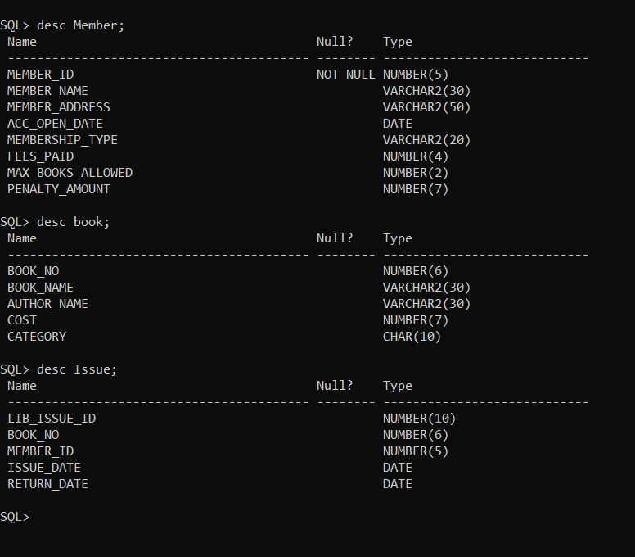

- Drop the Member table

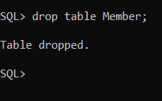

- Create the table Member again as per the schema description with the following constraints.

  - Member_Id – Primary Key
  - Membership_type - ‘Lifetime’,’ Annual’, ‘Half Yearly’,’ Quarterly’

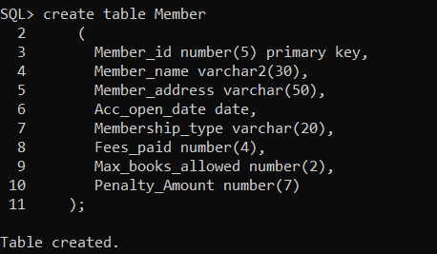

- Modify the table Member increase the width of the member name to 30 characters.

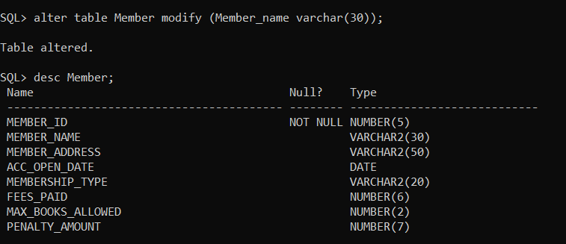

- Add a column named as Reference of Char(30) to Issue table.

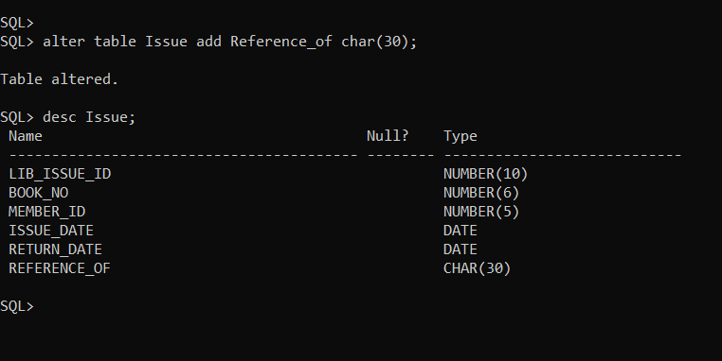

- Delete/Drop the column Reference from Issue.

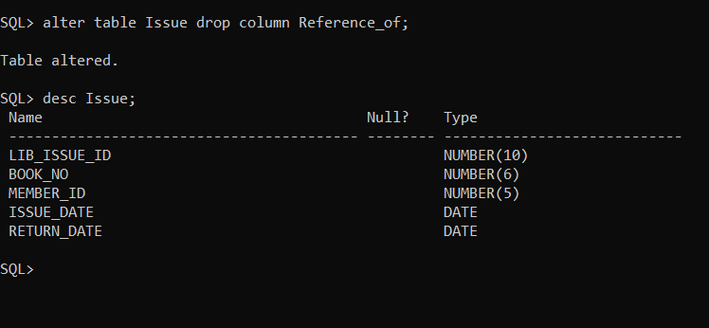

- Rename the table Issue to Lib_Issue.

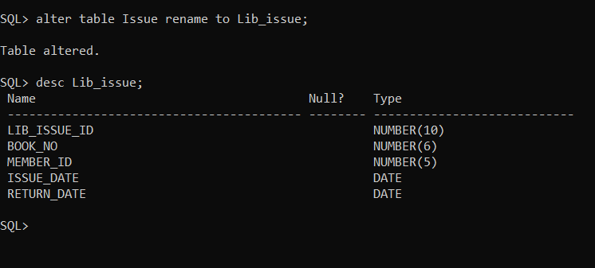

- Insert following data in table Member

Member ID | Member Name | Member Address | Acc_Open_Date | Membership_type | Fees_Paid | Max_Books  _Allowed | Penalty_  Amount
1 | Richa Sharma | Pune | 10-Dec-05 | Lifetime | 25000 | 5 | 50
2 | Garima Sen | Pune | Current date | Annual | 1000 | 3 | Null

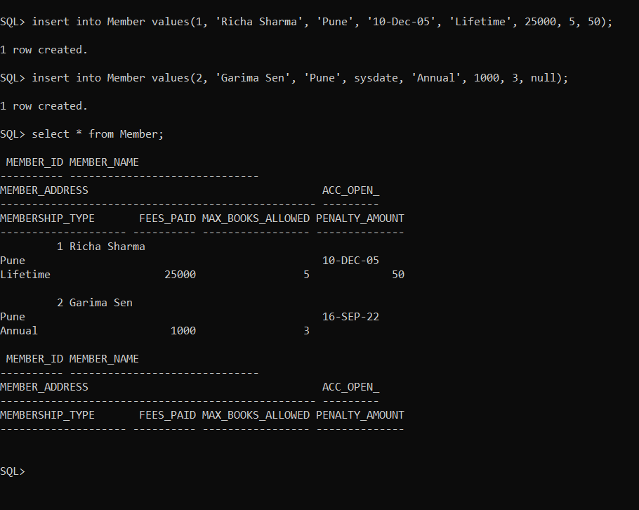

- Insert at least 5 records with suitable data and save it.

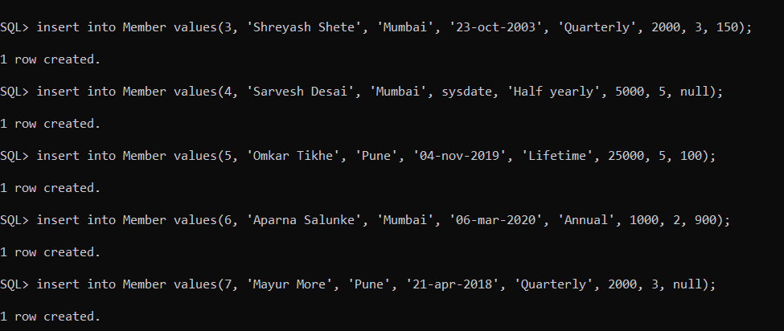
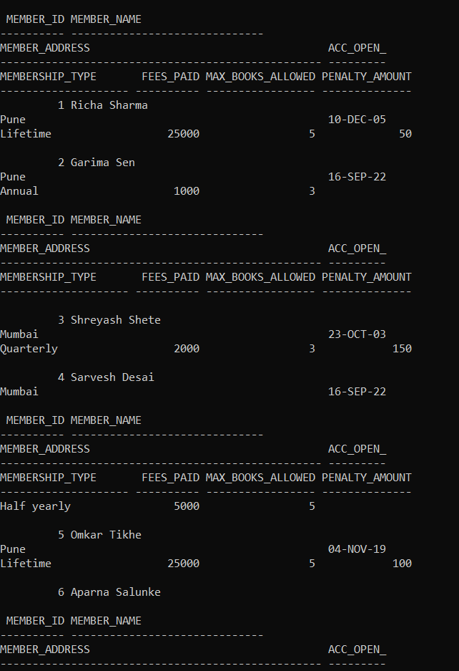
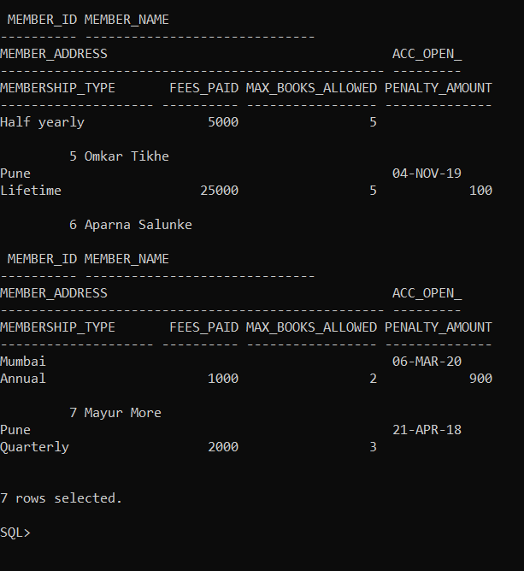

- Modify the column Member_name. Decrease the width of the member name to 20 characters. (If it does not allow state the reason for that)

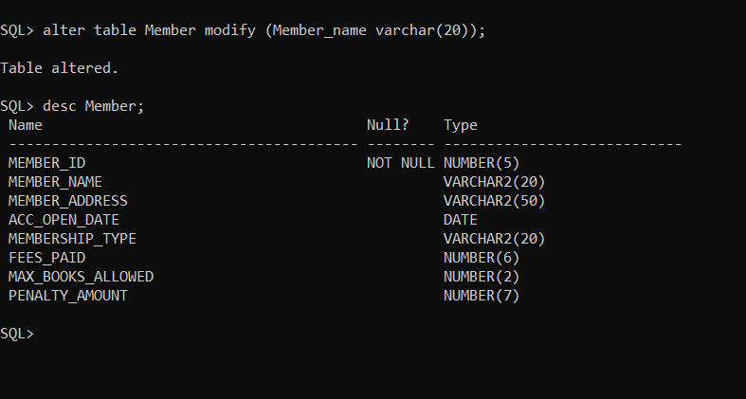

- Try to insert a record with Max_Books_Allowed = 110, Observe the error that comes. Report the reason for this error.

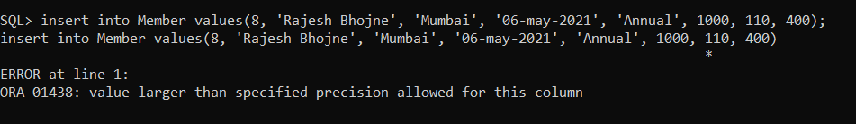

- Generate another table named Member101 using a Create command along with a simple SQL query on member table.

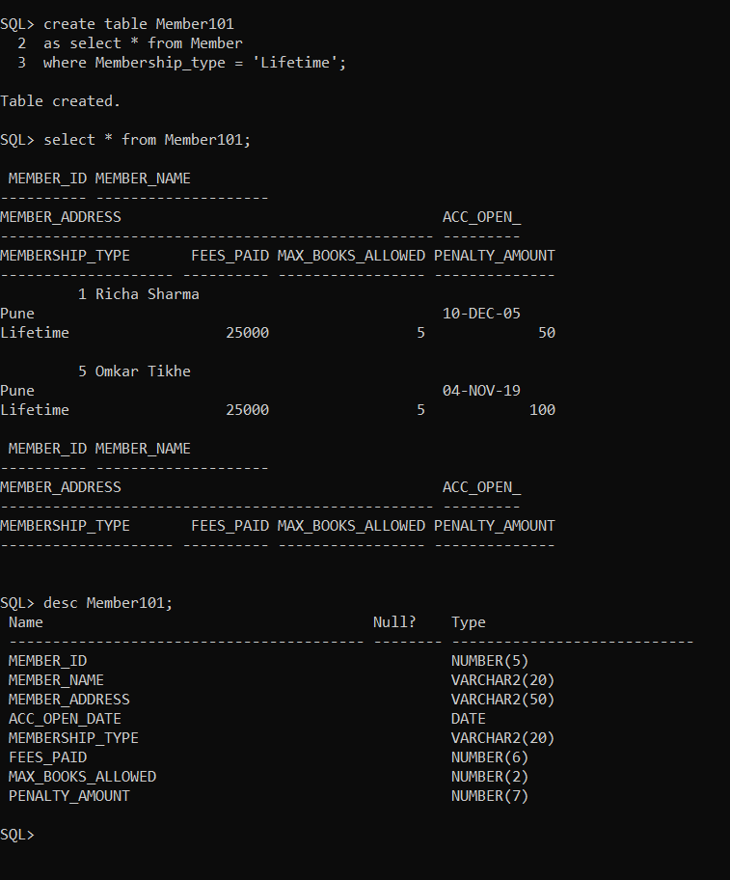

- Add the constraints on columns max_books_allowed and penalty_amt as follows (**)
  - max_books_allowed < 100
  - penalty_amt maximum 1000
Also give names to the constraints.

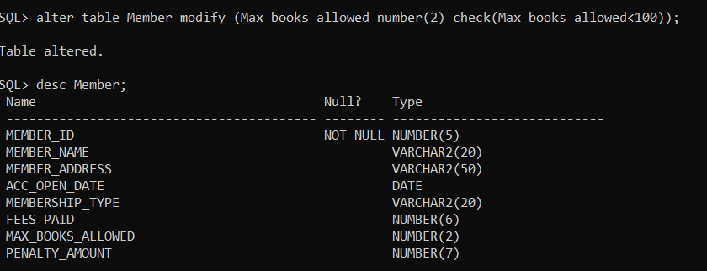

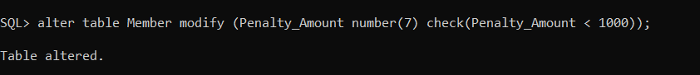

- Drop the table books.

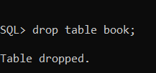

- Create table Books again as per the schema description with the following constraints.
- Book_No – Primary Key
- Book_Name – Not Null
- Category – Science, Fiction, Database, RDBMS, Others.

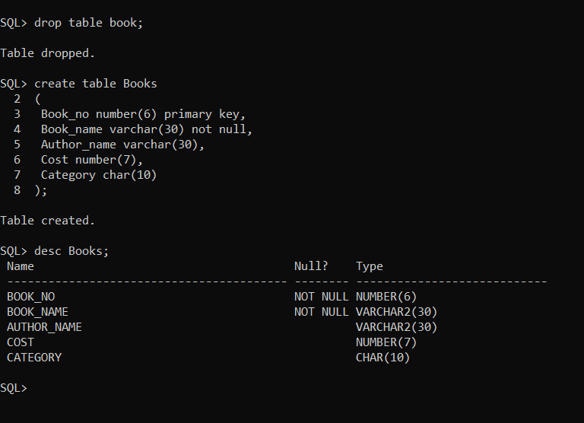

- Insert data in Book table as follows:

Book_No | Book Name | Author | Cost | Category
101 | Let us C | Denis Ritchie | 450 | System
102 | Oracle – Complete Ref | Loni | 550 | Database
103 | Mastering SQL | Loni | 250 | Database
104 | PL SQL-Ref | Scott Urman | 750 | Database

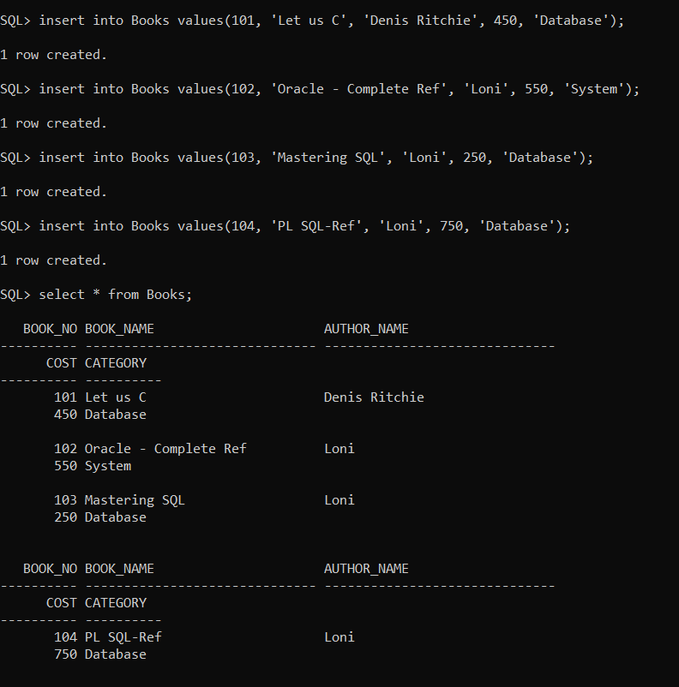

- Insert more records in Book table using & operator in the insert
statement.

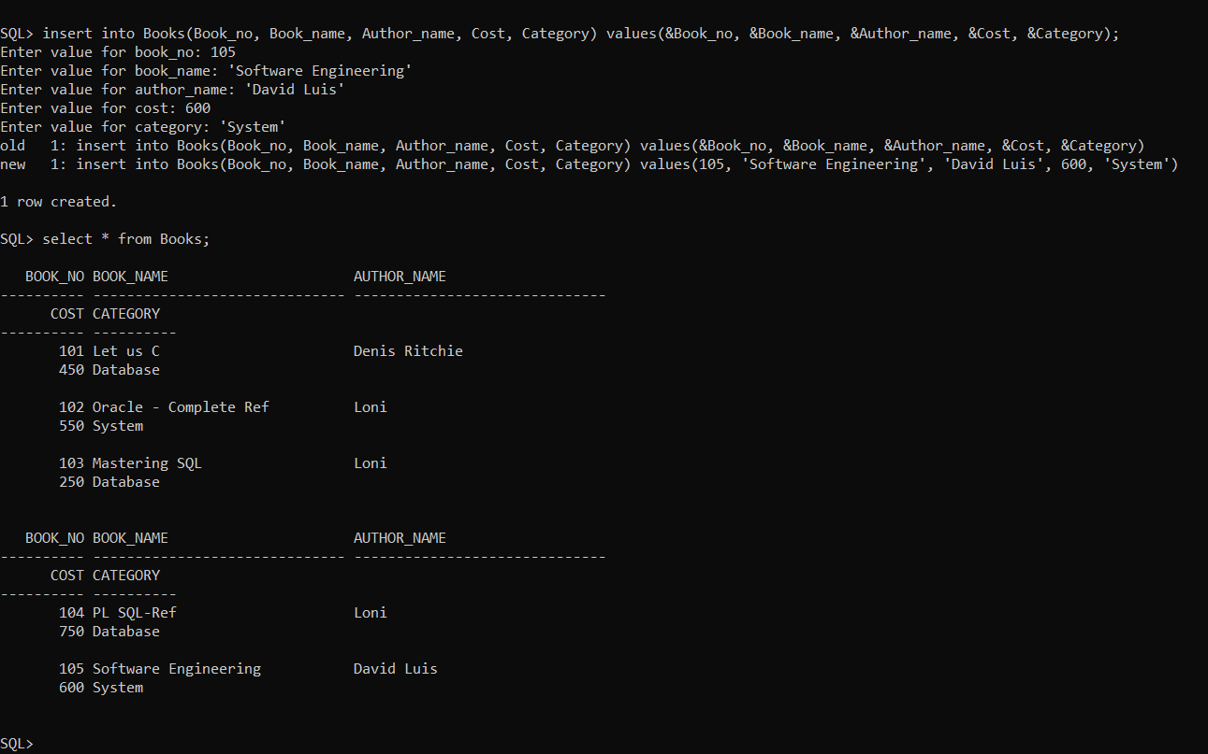

- Create table Book101 similar to Book in structure with no data in it.

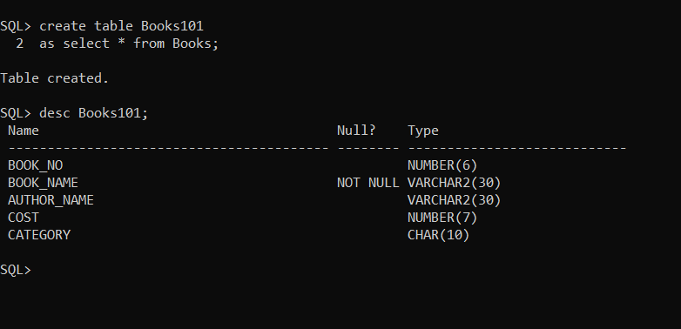

- Insert into Book101 all the data in Book table using Select
Statement.

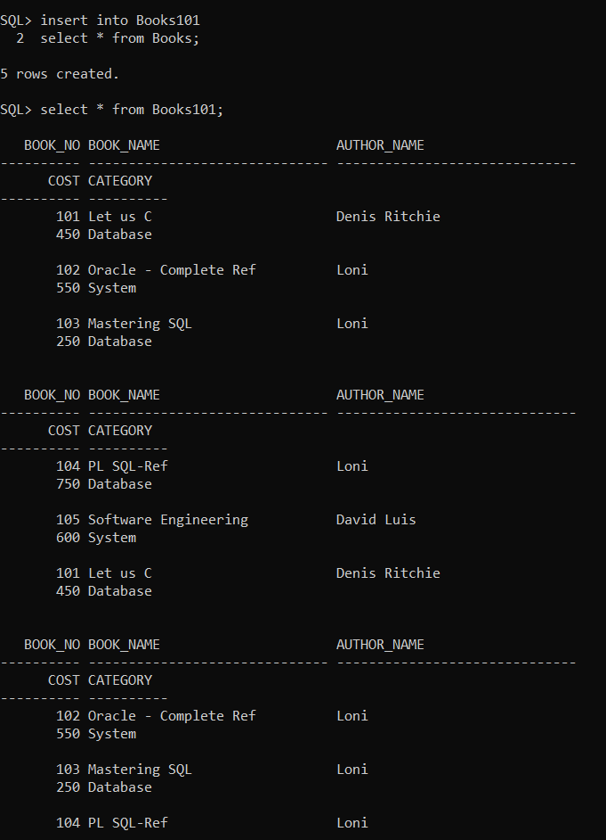

- Save all the data so far inserted in the tables.

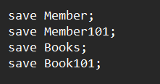

- View the data in the tables using simple SQL query.

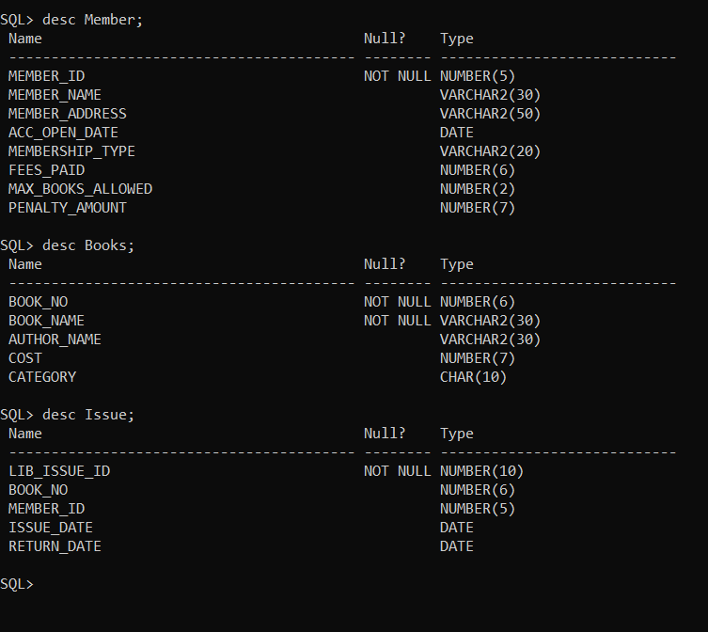

- Insert into Book following data.
105, National Geographic, Adis Scott, 1000, Science

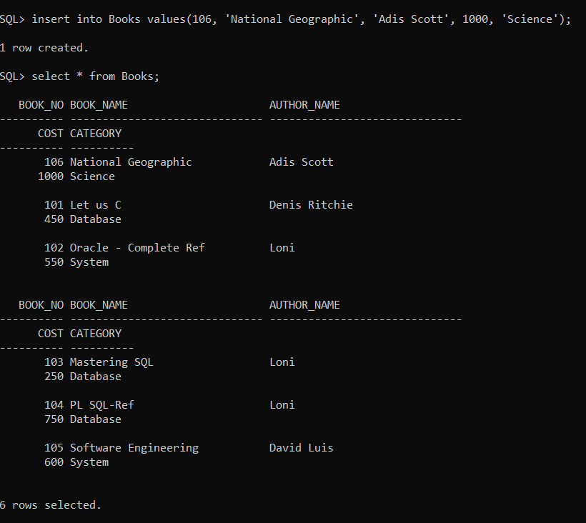

- Undo the last changes.

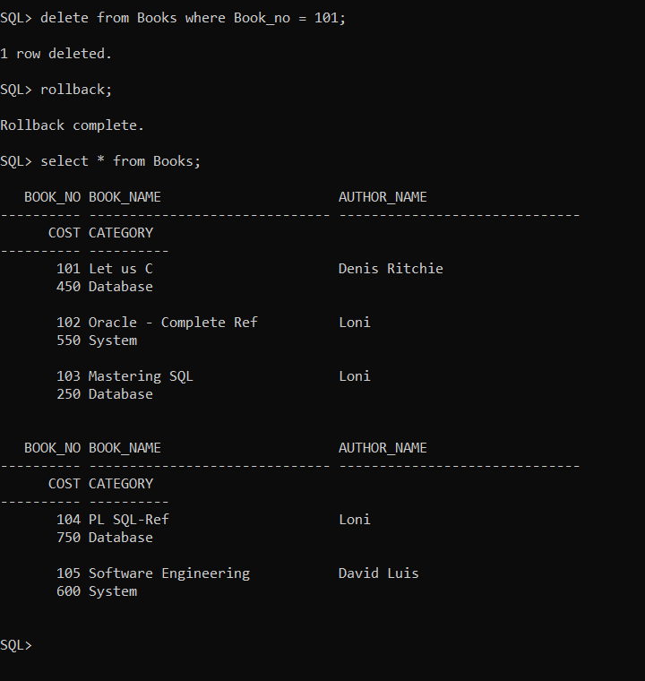

- Modify the price of book with id 103 to Rs 300 and category to
RDBMS.

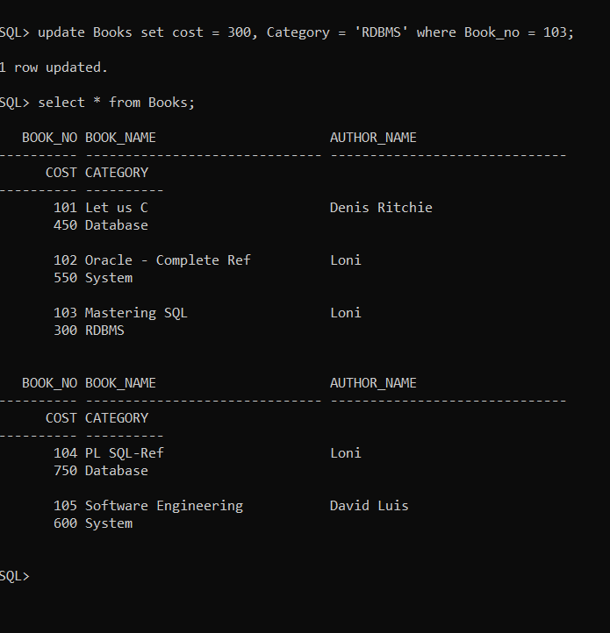

- Rename the table Lib_Issue to Issue.

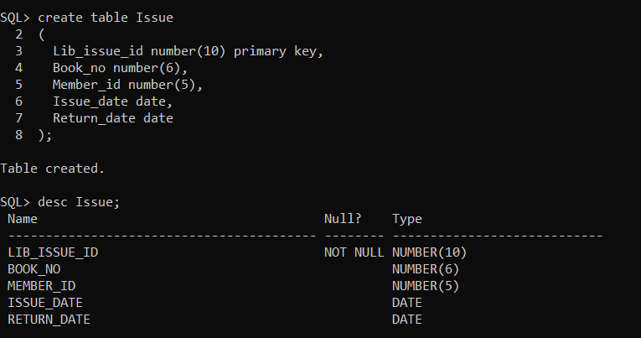

- Drop table Issue.

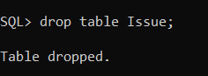

- As per the given structure Create table Issue again with following constraints.
    - Lib_Issue_Id-Primary key
    - Book_No- foreign key
    - Member_id - foreign key
    - Issue_date < Return_date

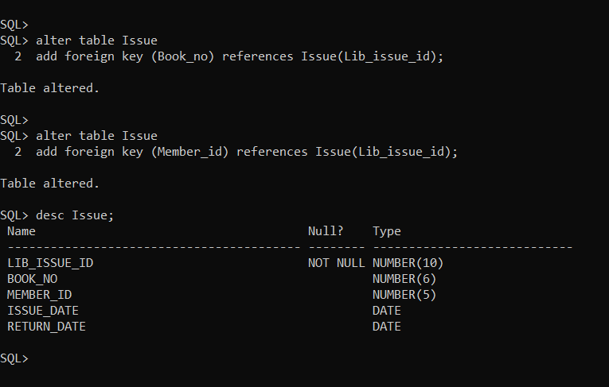

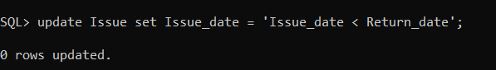

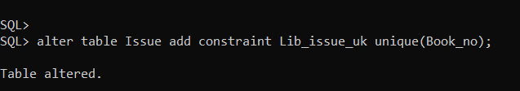

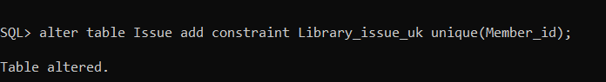

- Insert following data into Issue table. Note leave the column
Return_Date blank.

Lib_Issue_Id | Book No | Member ID | Issue Date | Return Date
7001 | 101 | 1 | 10-Dec-06
7002 | 102 | 2 | 25-Dec-06
7003 | 104 | 1 | 15-Jan-06
7004 | 101 | 1 | 04-Jul-06
7005 | 104 | 2 | 15-Nov-06
7006 | 101 | 3 | 18-Feb-06

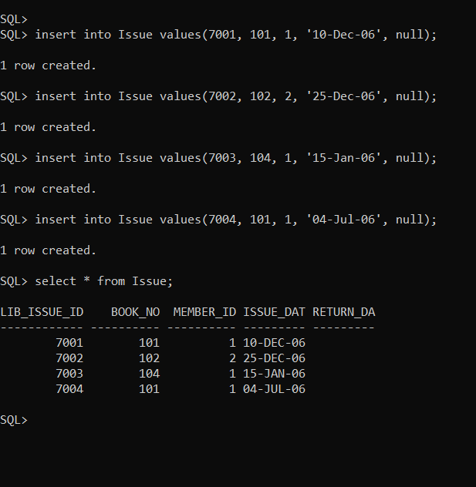

- Save the data.

- Disable the constraints on Issue table

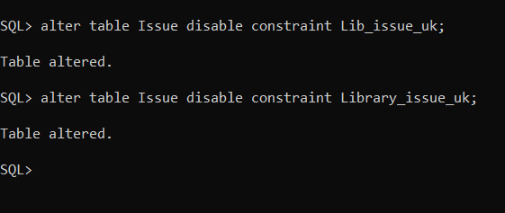

- Insert a record in Issue table. The member_id should not exist in
member table.

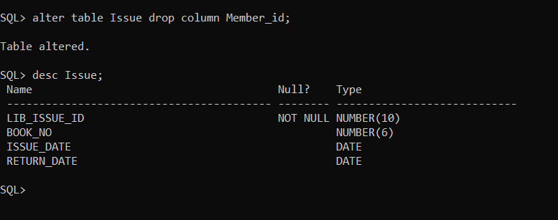

- Now enable the constraints of Issue table. Observe the error

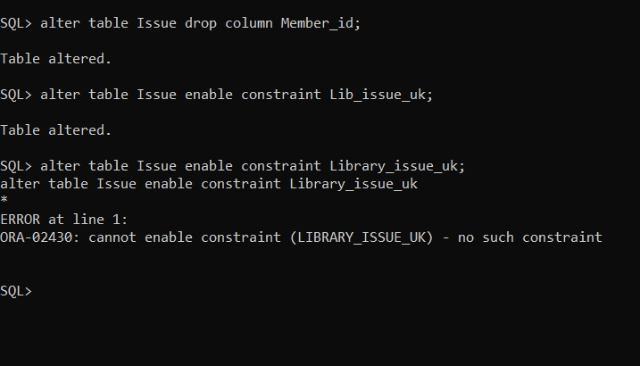

- Delete the record inserted at Q-32) and enable the constraints.

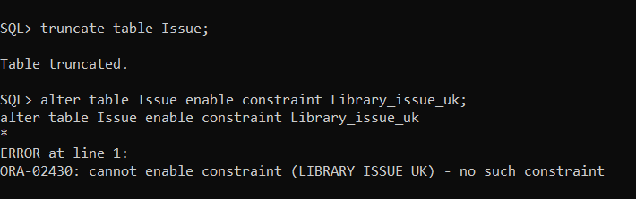

- Try to delete the record of member id 1 from member table and
observe the error .

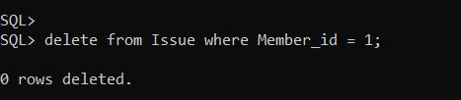

- Modify the Return_Date of 7004,7005 to 15 days after the
Issue_date.

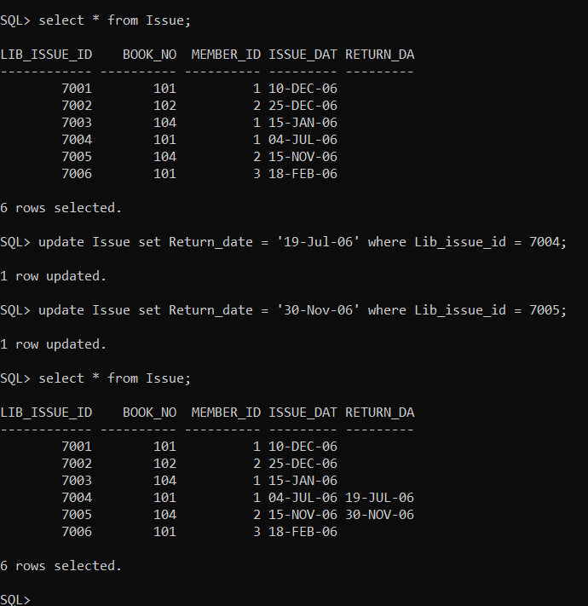

- Modify the Penalty_Amount for Garima Sen to Rs 100.

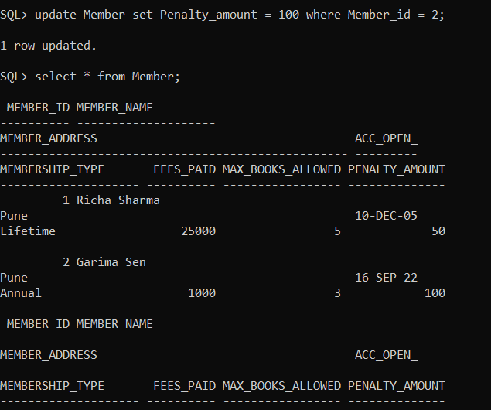

- Perform a save point X here.

- Remove all the records from Issue table where member_ID is 1
and Issue date in before 10-Dec-06.

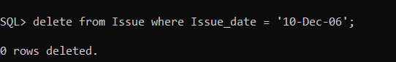

- Remove all the records from Book table with category other
than RDBMS and Database.

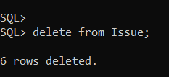
- Undo the changes done after savepoint X.
- Save all the changes done before X.
- Remove the table Member101.
- Remove the table Book101.

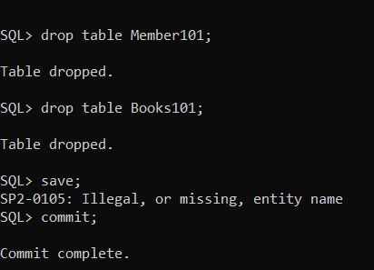

- View the data and structure of all the three tables Member,
Issue, Book.

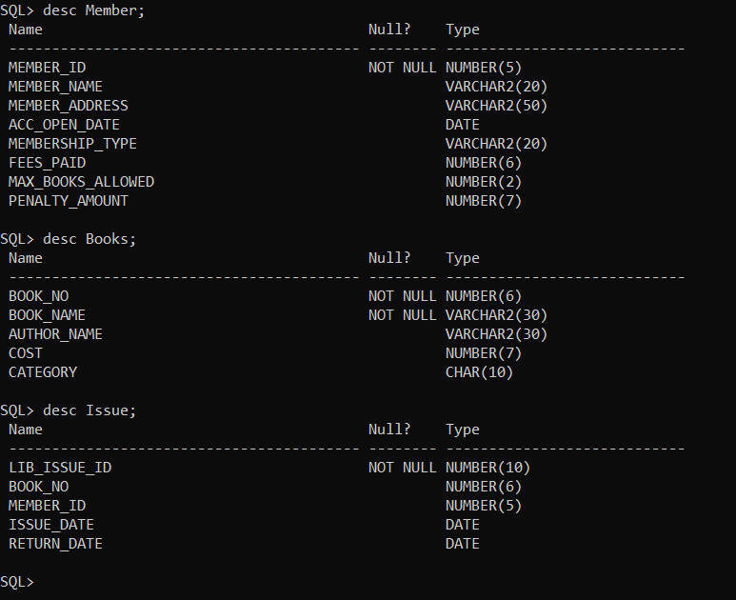

- Create a sequence no_seq of even numbers starting with 100
and ending with 200.

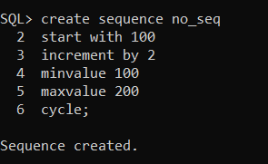

- Drop the above created sequence.

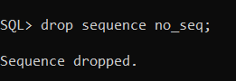

- Create a sequence book_seq starting with 101 and ending with 1000
And increamented by 1 without cycle.

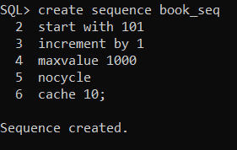

- Create a sequence member_seq starting with 1 and ending with 100
And increamented by 1 without cycle.

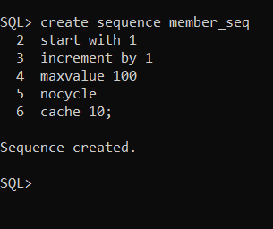

50) Drop the above created sequences.

